Reset Life Helper Service Worker Permissions and cache.

Select settings in Chrome and the “Privacy and security” entry.

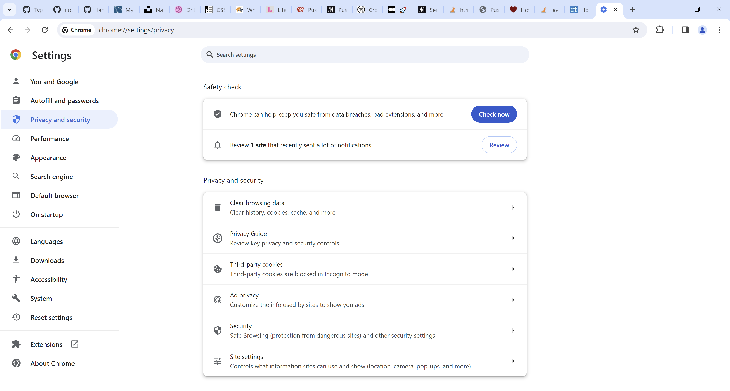

Select Site settings from the list. Then expand 127.0.0.1…

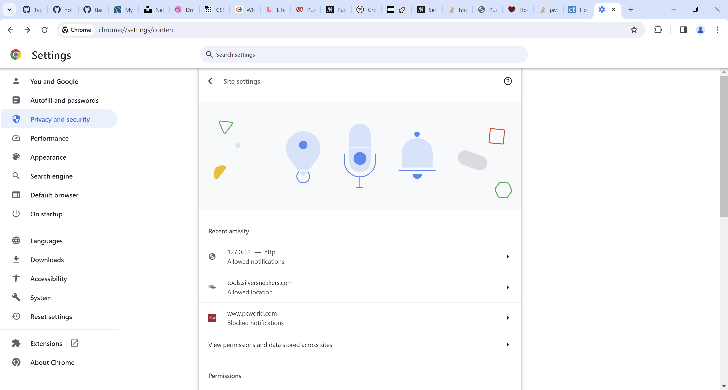

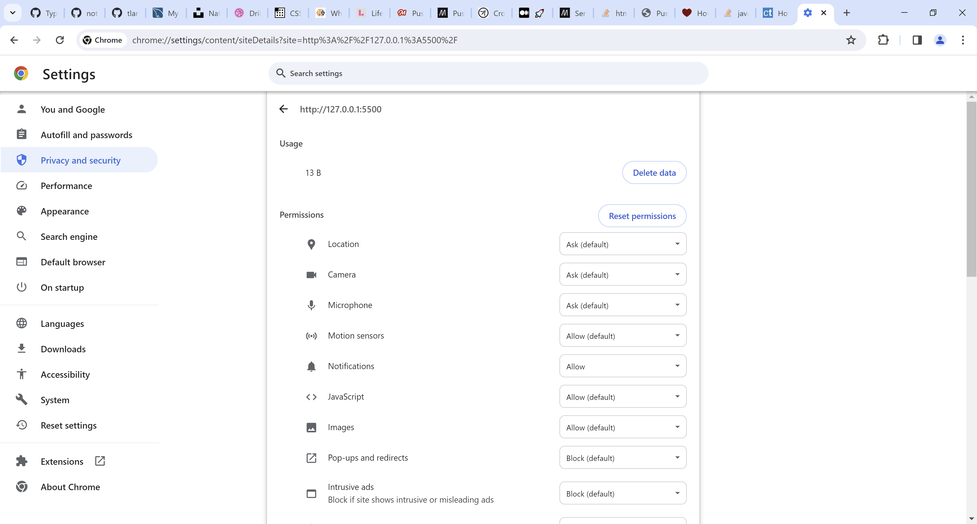

Change Notifications from Allow to Ask

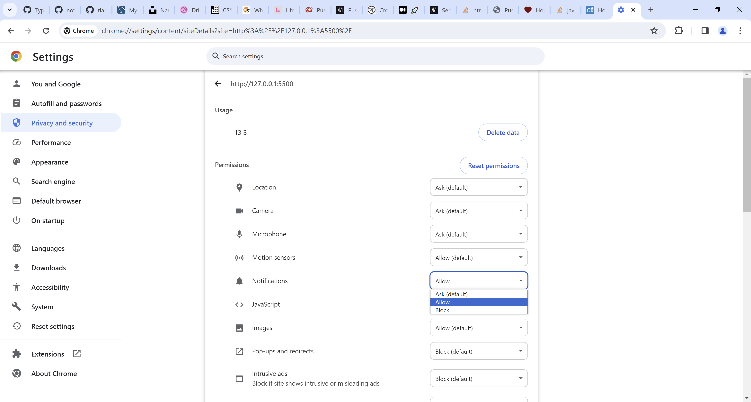

Finally, delete all cached data associated with the URL by clicking the “Delete data” button

